[capybararoom]

Playable Ad Production Requirement
Contents
Ⅰ Description 1
Ⅱ 试玩广告关卡配置 1
Ⅲ Playable Settlement 3
Ⅳ 注意事项 4

Ⅰ Description

Core Requirements:
- Using the game project source code and art assets provided by us, create a playable ad that mimics the gameplay of [Playable_Ad_For_Reference.html]
- [Playable_Ad_For_Reference.html] is included in the attachments
- Build it using LUNA, preserving the original game project's art as closely as possible
- Support both portrait and landscape orientations
- Text only needs to support English; if fonts are used in the project, use [LilitaOne-Regular.ttf] from the attachments
- If the player takes no action for 15 seconds, enter the [playable settlement]
- Must support the 3 ad networks: Applovin, Mintegral, and Google

Ⅱ Playable Ad Level Configuration

Scene Configuration:
- Use the [Leve8] bedroom scene from the original project:
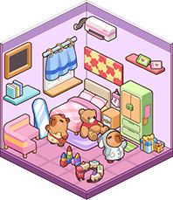

Gameplay Configuration:
- The gameplay must be modified to match [Playable_Ad_For_Reference.html]; the game only allows placing items indicated by the ghost guide outlines
- [Leve8] has a total of 25 items to be placed; all items must take part in the subsequent gameplay:
- Sticker_map08_a27_Prefab
- Sticker_map08_a06_Prefab
- Sticker_map08_a21_Prefab
- Sticker_map08_a09_Prefab
- Sticker_map08_a19_Prefab
- Sticker_map08_a20_Prefab
- Sticker_map08_a05_Prefab
- Sticker_map08_a10_Prefab
- Sticker_map08_a25_Prefab
- Sticker_map08_a08_Prefab
- Sticker_map08_a16_Prefab
- Sticker_map08_a02_Prefab
- Sticker_map08_a15_Prefab
- Sticker_map08_a23_Prefab
- Sticker_map08_a24_Prefab
- Sticker_map08_a03_Prefab
- Sticker_map08_a18_Prefab
- Sticker_map08_a07_Prefab
- Sticker_map08_a17_Prefab
- Sticker_map08_a22_Prefab
- Sticker_map08_a13_Prefab
- Sticker_map08_a12_Prefab
- Sticker_map08_a11_Prefab
- Sticker_map08_a28_Prefab
- Sticker_map08_a29_Prefab
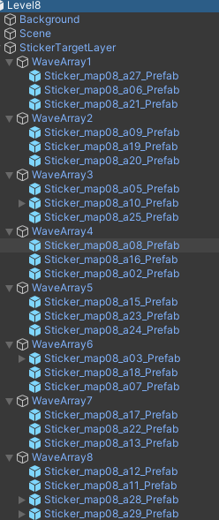

- All items to be placed, mimicking [Playable_Ad_For_Reference.html], are placed at the bottom of the main scene (portrait mode) / right side (landscape mode) in wave order when the game starts; portrait and landscape can be switched
- Place a panel (using the image common_bg_title.png) in the top-left corner of the game UI, showing the count of items the player has placed so far (out of 25)
- The interface layout is shown below:

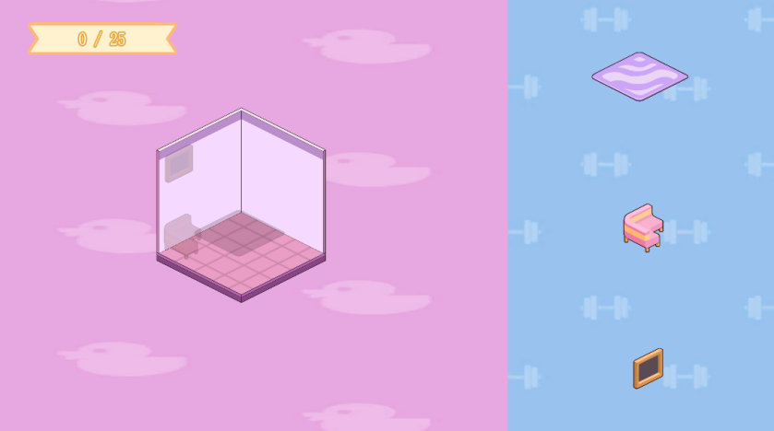
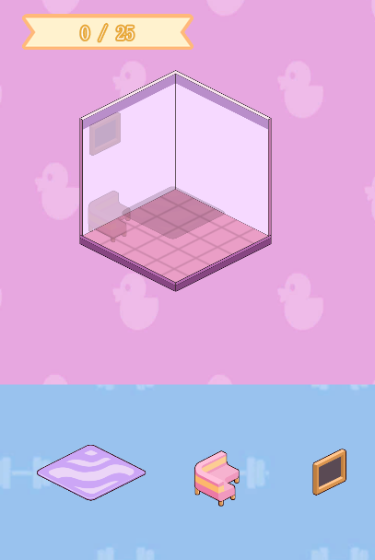
- Keep the ghost guide outlines from the original project
- After the player has placed all placeable items, enter the victory settlement page
- If the player takes no action for 15 seconds, enter the no-action settlement layout

Ⅲ Playable Settlement
- Please configure the playable ad settlement page according to the SDK and related documentation provided by us

Victory Settlement Layout:
- Place a black overlay at 50% opacity
- Place [title_bedroom.png] at the top
- Place [common_ic_map08_01.png] in the center
- Place [playnow_button.png] at the bottom
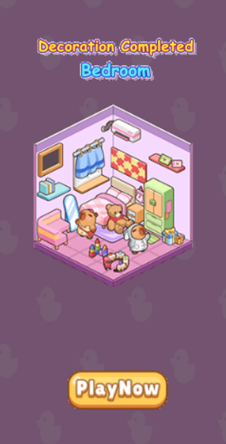

No-Action Settlement Layout:
- Place a black overlay at 50% opacity
- Place [title_try_again.png] at the top
- Place [map08_a01.png] in the center
- Place [playnow_button.png] at the bottom
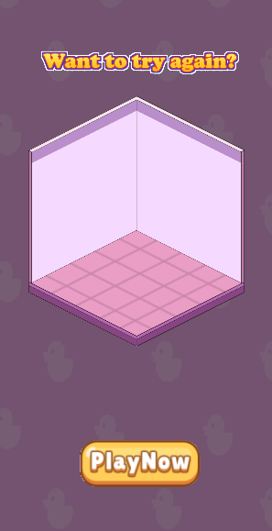

Ⅳ Notes
- The animation effects, VFX, etc. from the original project when items are correctly placed must be retained
- All sound effects from the original project must be retained

